* **Names and IDs:**
* Badr Elsayed - **22010664**
* Adham Anas - **22010601**
* Nour Khaled - **22011319**
* Ali El-Deen Maher – **22010934**
* **Steps required to run code:**
  1. Backend:
* Open the Backend folder using IntelliJ IDE or any other IDE, run the Application.java class.
  1. Frontend:
* Open the Frontend folder using visual studio IDE, then open the terminal of the IDE, and write “npm install” in the terminal.
* Then write “npm run dev” in the terminal to open the project, usually on port “http://localhost:5173/”
  1. Then you can use the application.
* **UML diagram:**

* **Design Patterns:**

1. Singleton design pattern

* This design pattern ensures that there is only one instance of the **Monitor** class throughout the application. This central **Monitor** instance manages the **observers**. Singelton helps conserve memory and enables reusability.

1. Observer design pattern

* This design pattern was used to implement a system where objects **(observers)** are notified of changes in the **network**. The **Monitor** class maintains a list of **observers**, and when the state of the **network** changes, all registered **observers** are updated accordingly.

1. Prototype design pattern

* This design pattern enables the cloning of **Machine, Queue, Product and Network** objects. It help maximize the efficiency of object creation by cloning from an existing template.

1. Snapshot design pattern

* This design pattern was implemented in the **NetworkMemento** and **History** classes. It allows capturing and restoring the state of the **network** at specific points in time.

1. Concurrency design pattern

* This design pattern was implemented in **Machine** and **Input** to handle parallel processing. The classes uses concurrency by using threads to manage and perform tasks asynchronously, allowing multiple machines to operate simultaneously.

**

* **Design Patterns snapshots:**
  1. **Concurrency**

**Generating product thread:**

**Hint : (including also the call of the originator to notify observers)**

**Starting or receiving products at the machine thread**

**Hint : (including also the call of the originator to notify observers)**

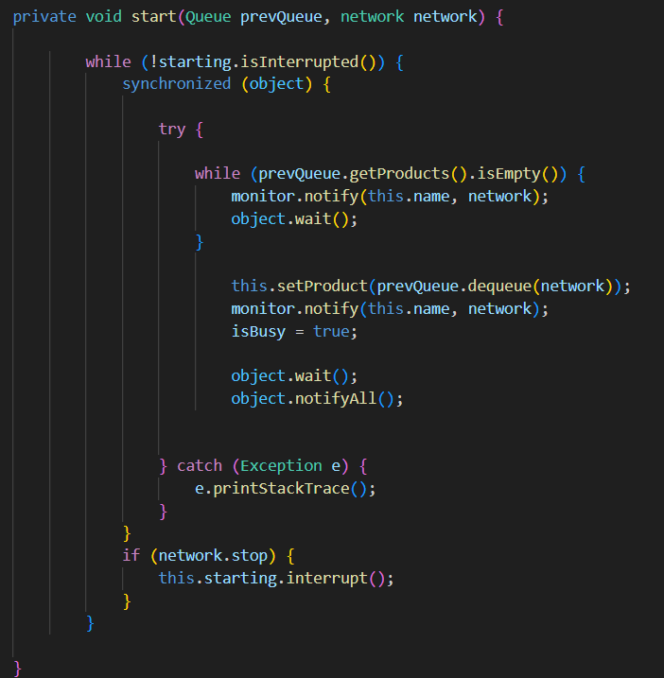

**Finishing or producing products at the machine thread**

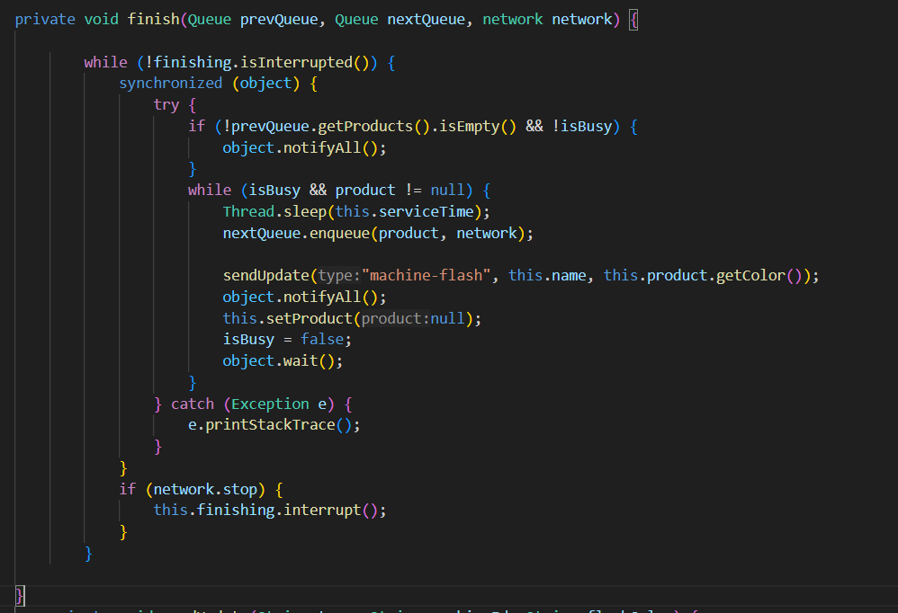

**Working of the 2 threads concurrently**

* 1. **Snapshot (Memento)**

**caretaker (history)**

* 1. 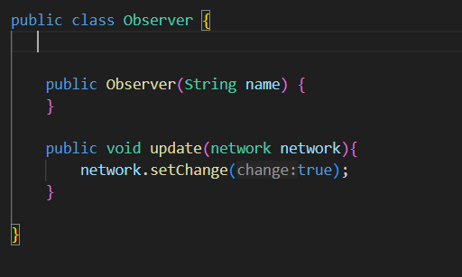**Observer**

**Monitor (manager for observer)**

* **Design decisions:**
* Input (First) Queue must be Q0
* User can stop the simulation completely but can’t pause/resume it.
* A machine can only output in a single Queue.
* Machine time is assumed to be in range of [5, 25] seconds.
* Q0 input federate is in range of [5, 10] seconds.
* Number of input products has no limits.
* **Snapshots UI and User guide:**
  1. Start by **adding** the Queues and Machines that you want, when you click an “Add” button, a Queue/Machine will appear on the board.

* 1. Rearrange the Queues and Machines by dragging them, then connect them by grabbing and dragging one end to the other.

Note: The flow of simulation is from right to left, meaning that Q0 is the input and Q1 is the final output, so keep that in mind!

* 1. Made a mistake? Delete a Queue / Machine or an edge by selecting it and clicking “**Backspace**” on the keyboard, you can also see this info in the “**Shortcuts**” button in case you forgot what to press.

* 1. When all good, press “**Start Simulation**” to begin. You’ll see the current number of products in each Queue and the time a Machine takes to service/process a product.

Each machine will flash the color of the product it’s inside when it finishes servicing the product,

Each product from Q0 up till Q5 will have a unique random color.

* 1. Press “**Stop Simulation**” to stop the simulation.

Press **“Clear All”** to start fresh (will obviously stop simulation).

You can start simulation again with new random values and colors when you click “**Start Simulation**”.

Or click “**Replay Previous Simulation**” to replay the last played simulation with the same values and colors!

* 1. Lastly, you may have wondered what’s in the bottom left.

It’s a control panel! You can

* + - 1. Zoom in
      2. Zoom out
      3. Fit view
      4. Toggle interactivity, which includes (Select, Delete, Drag)

The bottom right is just a mini-map (overview) of the whole board.